Helena Bonett

Hepworth, Dame (Jocelyn) Barbara (1903–1975)

Barbara Hepworth was a sculptor, draughtsperson, painter and printmaker, born in Yorkshire but based in London and St Ives in Cornwall, with a career spanning the late 1920s to her death in 1975. Known for her pioneering abstract sculpture – including pierced forms and multipart arrangements – Hepworth was one of the leaders of the modernist movement in Britain. Her work also shares a confluence of ideas with modernists on the continent, many of whom she first met in France in the 1930s. At this time her work was predominantly carved in wood and stone, but from the 1940s Hepworth began working with new materials, employing stringing and colour in her carved pieces, and, in the following decade, using plaster and bronze to create large-scale works. She was a member of many groups, including Abstraction-Création in Paris, the 7 & 5 Society and Unit One in London, and the Penwith Society of Arts in St Ives. Engaged in a male-dominated art form, Hepworth struggled to gain the same recognition as contemporaries such as Henry Moore. Despite these difficulties, however, she gradually gained a reputation on the international stage. Today, Hepworth remains one of Britain’s most famous and best-loved sculptors.

Jocelyn Barbara Hepworth was born on 10 January 1903 in Wakefield, Yorkshire, and studied at Leeds School of Art and the Royal College of Art, London, where her contemporaries included Henry Moore. While in Italy on a scholarship, Hepworth learnt stone carving and married the sculptor John Skeaping (they had one child who later died on RAF duty). Upon returning to London, she held her first exhibition, with Skeaping, in 1928. Hepworth’s work at this time was figurative, carved out of stone or wood, with a formal, hieratic quality, as in Figure of a Woman (1929–30, Tate).

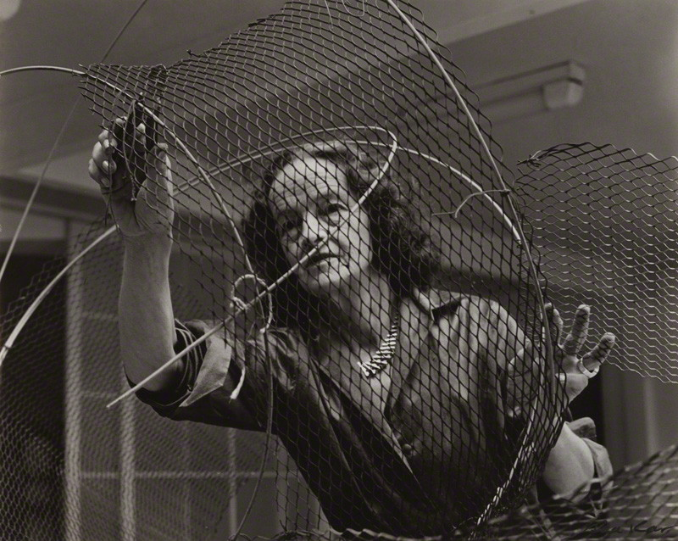

Ida Kar (1908–1974), Barbara Hepworth at Work on the Armature of a Sculpture, 1961
Vintage bromide print, 202 x 252 mm
National Portrait Gallery, London (NPG x88513)
© National Portrait Gallery, London

The couple separated and Hepworth partnered with the painter Ben Nicholson, with whom she had triplets and who introduced her to Christian Science. They lived at 7 The Mall, Hampstead, where a community of modernist artists formed, including Henry and Irina Moore, the art writer Herbert Read, the constructivist sculptor Naum Gabo and, later, the abstract painter Piet Mondrian. They also visited France together over the decade where they met artists including Brancusi, Braque, Calder, Kandinsky, Mondrian and Picasso. A breakthrough came when Hepworth first pierced the block, in Pierced Form (1932, destroyed). She also began creating multipart abstract sculptures, sometimes with incised figurative marks, as in Two Forms (1933, Tate). Hepworth and Nicholson demonstrated their commitment to abstraction in joint exhibitions in 1932–33 and also collaborated with others on the publication Circle: International Survey of Constructive Art (1937). Left-wing in her political views, Hepworth also contributed to Artists’ International Association exhibitions and designed a Monument to the Spanish War (1938–39, destroyed).

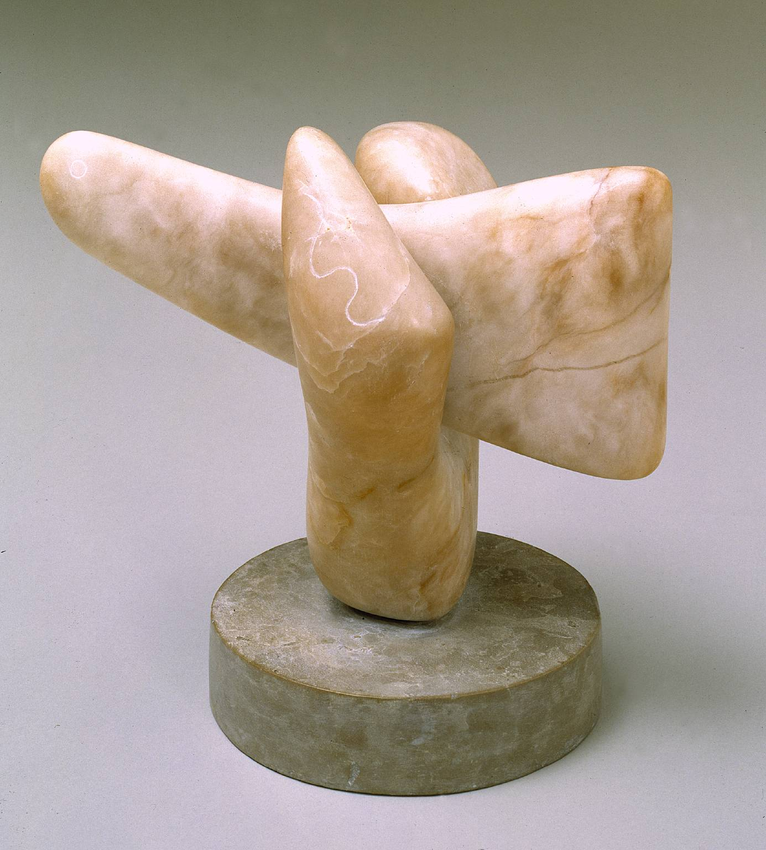
Barbara Hepworth (1903–1975), Two Forms, 1933
Alabaster on limestone base, 260 x 296 x 176 mm
Tate (T07123)
© Bowness, Hepworth Estate. Photo © Tate

Just before the outbreak of war, Hepworth and her family moved to Cornwall at the invitation of the writer Adrian Stokes (Gabo also joined them, working closely alongside Hepworth in 1939–46). Hepworth began to introduce colour and stringing into her work and was also influenced by the Cornish landscape, as in Pelagos (1946, Tate). In 1943, Hepworth’s first retrospective exhibition was held in Leeds. In 1947–49, she made a series of around seventy figurative drawings in hospitals, at the invitation of her friend, the surgeon Norman Capener.

Living initially in Carbis Bay, Hepworth acquired Trewyn Studio in St Ives in 1949, where she lived and worked until her death in 1975. Now with more space and able to work outside, Hepworth could sculpt on a larger scale. She was commissioned to carve Contrapuntal Forms, standing at over three metres in height, for the 1951 Festival of Britain. For the first time, Hepworth employed assistants, which increased her productivity over the coming decades, and who would include Terry Frost, John Milne, Denis Mitchell and John Wells.

The musical title of Contrapuntal Forms reflects Hepworth’s new friendship with the South African composer Priaulx Rainier, who also helped to shape the subtropical garden at Trewyn and composed music for the first film on Hepworth, Figures in a Landscape: Cornwall and the Sculpture of Barbara Hepworth (Dudley Shaw Ashton, 1953). With Rainier and the composer Michael Tippett, Hepworth organised the St Ives Festival of Music and the Arts in 1953. Tippett later asked Hepworth to design the sets and costumes for The Midsummer Marriage, which premiered at the Royal Opera House in 1955.

In the 1950s Hepworth began to experiment with using sheet metal, as in Orpheus (Maquette 2) (Version II) (1956, edition 1959, Tate), as well as creating organic, flowing shapes in plaster over aluminium armatures cast in bronze, as in Sea Form (Porthmeor) (1958, Tate). Quicker to sculpt than wood or stone, these new materials also allowed Hepworth to respond to the increasing demand for her work, both in Britain and abroad.

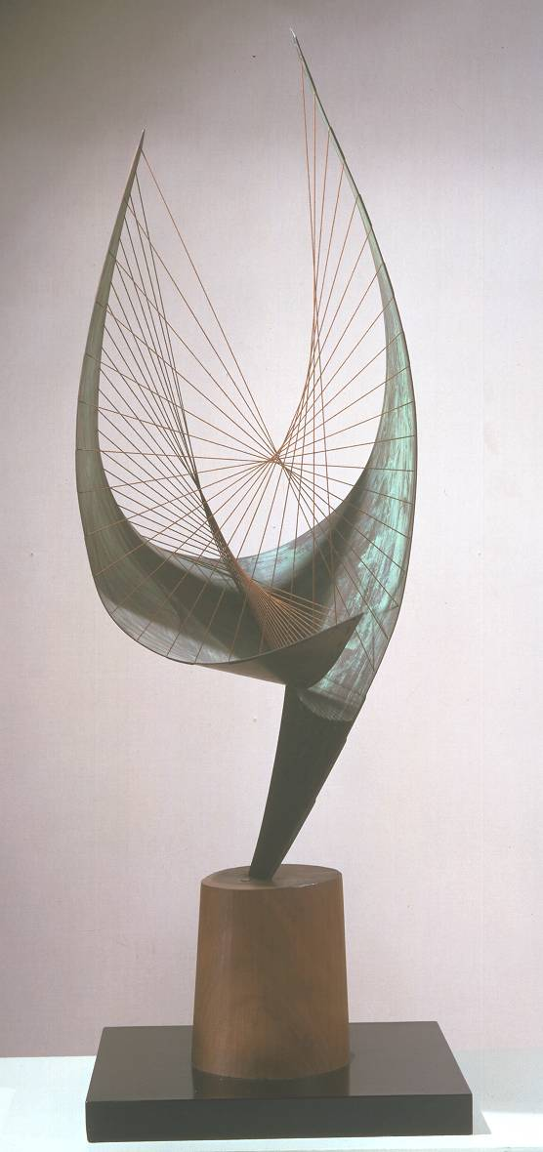
Barbara Hepworth (1903–1975), Orpheus (Maquette 2) (Version II), 1956, edition 1959
Copper and cotton string on wooden base, 1149 x 432 x 415 mm
Tate (T00955)
© Bowness, Hepworth Estate. Photo © Tate

In 1961 Hepworth acquired a former Palais de Danse, opposite Trewyn Studio, where she worked on large-scale public commissions, including Winged Figure (1961–62, John Lewis, London) and Single Form (1961–64, United Nations, New York). A BBC documentary made by John Read, first broadcast in 1961, shows Hepworth at work in her studios, with sculptures in Trewyn and the Palais, and emphasises the influence of the Cornish landscape. The words Hepworth speaks in this documentary were adapted for her Pictorial Autobiography (1970). Towards the end of her life, Hepworth created some complex, multipart sculptures, as in The Family of Man (1970), Conversation with Magic Stones (1973) and Fallen Images (1974–75, Tate).

Hepworth died in a fire in her first-floor studio at Trewyn on 20 May 1975. In accordance with her wishes, Hepworth’s executors established the Barbara Hepworth Museum and Sculpture Garden at Trewyn, which opened in 1976. The museum has been popular since its opening and has been managed by Tate since 1980. In 2011, a newly built gallery, The Hepworth Wakefield, opened in the sculptor’s hometown with a significant donation of 44 full-size working models from the Hepworth Estate.

References and further reading

Hepworth, B. and Read, H. (1952), Barbara Hepworth: Carvings and Drawings, London: Lund Humphries

Hodin, J.P. and Bowness, A. (1961), Barbara Hepworth, London: Lund Humphries

Hepworth, B. (1970, revised 1978, republished 1985), A Pictorial Autobiography, London: Tate Publishing

Bowness, A. (1971), The Complete Sculpture of Barbara Hepworth 1960–69, London: Lund Humphries

Thistlewood, D. (ed.) (1996), Barbara Hepworth Reconsidered, Liverpool: Liverpool University Press and Tate Gallery Liverpool

Curtis, P. (1998), Barbara Hepworth, London: Tate Publishing

Gale, M. and Stephens, C. (1999), Barbara Hepworth: Works in the Tate Gallery Collection and the Barbara Hepworth Museum, St Ives, London: Tate Publishing (entries online http://www.tate.org.uk/art/artists/dame-barbara-hepworth-1274)

